**Title:** Multivariate mapping of genotype-by-environment interactions identifies two environmental drivers of flowering in switchgrass (*Panicum virgatum*)

**Authors**: Alice MacQueen*, Li Zhang*, Jason Bonnette, hosts of common gardens, Tom Juenger

**Addresses**: The University of Texas at Austin

**Target Journal:** New Phytologist

**Possible Friendly Reviewers/Reviewers:** Sarah Urbut, Annie Schmidt, Jiaming Yu, Ben Blackman, Dan Woods, James Schnable, Jill Andersen (UGA)

**NP editor:** John Stinchcombe

Total Word Count: 6457

Introduction Word Count: 820

Materials and Methods Word Count: 2302

Results Word Count: 2527

Discussion Word Count: 808

Number of Figures: 4

Number of Tables: 2

Supporting Information: 1 Figure (green-up variance components analysis), 1-4 Tables (SNP annotations)

**Summary**

* Plant phenological timings are major fitness components affected by multiple environmental cues; thus, phenological traits can have important genotype-by-environment (GxE) interactions. Here, we map the genetic basis of, and assign environmental drivers to, GxE in phenology in two highly divergent switchgrass (*Panicum virgatum*) populations.
* We evaluate the genetic basis of green-up and flowering as functions of environmental cues (e.g. daylength, temperature) using a diversity panel grown at eight common gardens spanning the central United States. We use multivariate adaptive shrinkage (mash) to determine the prevalence of and map the genomic effects covarying with environmental cues and/or other data-driven effects.
* A fraction of Gulf population SNPs affecting flowering covaried with photoperiod cues, while a fraction of Midwest upland population SNPs affecting flowering covaried with cumulative growing degree days. An independent four-way cross of two Gulf and two Midwest individuals mapped 23 additive QTLs for flowering at the same common gardens, all with significant mash associations and ten with enrichment of highly significant mash associations.
* We demonstrate that we can identify QTL with GxE and assign them to specific environmental drivers and/or data-driven patterns not connected to environmental cues. We highlight loci that could change flowering responsiveness to photoperiod cues in switchgrass.

Key Words: flowering time, GxE (genotype-by-environment) interactions, switchgrass, *Panicum* *virgatum*, photoperiod

**Introduction**

The timing of floral development is a major component of plant fitness affected by multiple external environmental cues (e.g. temperature, daylength, and water availability) that signal existing or upcoming growing conditions. Genetic responses to these cues determine the speed, timing, and energy apportioned to reproductive growth and shape both the individual’s lifespan and its lifetime production of viable seed. Global climate forcing is increasing temperatures and causing more extreme weather events, such as droughts, heatwaves, and severe rain events (Ummenhofer and Meehl 2017). These events will alter both the timing of reproductive development and the reliability of the environmental signals that plants use to cue flowering. It is thus of increasing importance that we understand the environmental cues driving floral development and the genetics underlying flowering responses to understand the genetic potential for adaptation to novel, changing environments.

Day length (or photoperiod) is one of the most predictable environmental cues, and plants sense day length to gauge diurnal and seasonal time and to initiate reproductive development. Photoperiod responses can be facultative or obligate, and these responses are typically classified into short day, long day, and day neutral types. Short day plant flowering is cued in day lengths below a critical maximum threshold, while long day plant flowering is cued in day lengths above a critical minimum threshold. In contrast, day neutral plants flower independently of a photoperiod signal. Species with wide natural distributions can segregate for multiple distinct photoperiod-related flowering responses: distinct populations of sunflower (*Helianthus annuus*) exhibit day-neutral, facultative short day, and facultative long-day responses, which vary with their environments (Blackman 2013; Henry, Watson, and Blackman 2014). Switchgrass (*Panicum virgatum*) is considered a short-day plant with reproductive development strongly linked to day of the year. However, as part of its wide environmental adaptation across the eastern half of North America, its photoperiodicity has been predicted to differ by plant latitude of origin (Parrish and Fike 2005).

Phenologically distinct genetic responses in different environments – genotype by environment interactions, or GxE – are key outputs of selection driving adaptation to local environments. Methodology commonly employed to study natural variation in GxE includes genetic studies using common gardens, reciprocal transplant experiments between contrasting environments, and/or environmental manipulations. These methods have been used in wild species to uncover widely varying genetic responsiveness to photoperiod-cued flowering (Brachi et al. 2010; Henry, Watson, and Blackman 2014; Blackman 2013; Ågren et al. 2017; Dittmar et al. 2014). In crop species, natural variation in flowering has been mapped using these and other strategies (Li et al. 2018; Romero Navarro et al. 2017), and altering the timing of flowering has been a major crop improvement strategy to adapt crops to local or future environments (Jung and Müller 2009). Changing flowering responsiveness to photoperiod cues has allowed geographic range expansion and increased yields in a number of cereal species (Turner et al. 2005; Faure et al. 2012; Hung et al. 2012; Zakhrabekova et al. 2012; Yang et al. 2013) and other crops (Pin and Nilsson 2012; Weller et al. 2012). In switchgrass, it has been broadly recognized that genetic differences in flowering date and photoperiod response will be an early point of exploitation in biomass crop breeding. Flowering date was mapped prior to the release of the genome using diversity panels of upland individuals, and using upland by lowland crosses (Tornqvist et al. 2018; Grabowski et al. 2017; Taylor et al. 2018; Lowry et al. 2019; Milano, Lowry, and Juenger 2016).

Recent statistical advances in studying phenological GxE have involved determining critical environmental indices before the phenological event occurs (Li et al 2018). Most studies of flowering GxE focus on finding a single, best fitting form of genotype-environment covariance, even though we expect different genetic subpopulations, and even different genomic regions, to have evolved distinct patterns of GxE. Additionally, despite theoretical models that local adaptation should involve antagonistic pleiotropy, or sign-changing GxE, at the level of individual loci (Levene 1953; Felsenstein 1976; Kawecki and Ebert 2004; Hedrick 1986), previous work has found limited evidence of antagonistic pleiotropy, and in fact has suffered from a known statistical bias that reduced detection of antagonistic pleiotropy. Thus, despite substantial interest in the frequencies of various forms of GxE, the prevalence of antagonistic pleiotropy relative to other forms of GxE remains unknown.

Here, we grow and phenotype a diversity panel of hundreds of distinct switchgrass genotypes, clonal replicates of which were planted at eight common garden sites across 17 degrees of latitude. We use this panel to interrogate environmental mechanisms controlling green-up and flowering using multivariate adaptive shrinkage (mash), which allows us to specify multiple kinds of environmental covariance and does not have a statistical bias in detecting frequencies of different forms of GxE. We then use an outbred pseudo-F2 cross to confirm our genetic mapping of GxE for flowering. Taken together, our results allow us to describe the environmental cues, genes, and alleles affecting flowering across two divergent natural populations of switchgrass.

**Materials and Methods**

In 2019, we genetically mapped two phenological traits in two mapping populations, a diversity panel and a pseudo-F2 cross, planted at eight common garden sites. We first describe the phenological trait measurements and the eight common garden locations in common in the two mapping populations. We introduce the mapping populations, then cover the additional methods used to detect patterns of GxE in the diversity panel in greater detail.

*Phenological trait measurements and environmental functions of these measurements*

Over the course of one season, switchgrass typically produces a single flush of tillers, which all become reproductive after a period of vegetative development, and cease biomass accumulation upon completion of floral development (Esbroeck, Hussey, and Sanderson 2003). We scored green-up date as the day of the year when 50% of the tiller area of the crown of the plant cut the previous year had green growth. Flowering date was the day of the year when 50% of the plant tillers had panicles undergoing anthesis. We scored plant green-up and flowering at eight common gardens every two days.

We scored green-up and flowering as functions of Julian date, then linked these dates to multiple environmental factors. We defined flowering as functions of eight variables: ‘flowering date’ (Julian date), cumulative growing degree days (GDD) between green-up and flowering dates (‘flowering GDD’), day length on the flowering date (‘flowering daylength’), change in daylength relative to the previous day on the day of flowering (‘flowering daylength change’), and four measures of cumulative rainfall: cumulative rainfall between green-up and flowering, and in the one day, three days, and five days before flowering (Table 1). Cumulative GDD was calculated as GDD = $\sum_{GR}^{FL}{max\left(T_{mean}−T_{base},0\right)}$, where Tmean is the daily average temperature, Tbase is the base temperature of 12 °C for switchgrass, GR is green-up date, and FL is flowering date (Kiniry et al. 2005; Behrman et al. 2013). On a specific day, if Tmean is less than Tbase, the GDD for that day is 0; if Tmean is bigger than Tbase, the GDD for that day is the difference between Tmean and Tbase. We also defined green-up as functions of seven variables: ‘green-up date’ (Julian date), cumulative GDD for the five, ten, or eighteen days prior to green-up, and the average air temperature for the five, ten, or eighteen days prior to green-up.

*Common gardens*

The eight common gardens that grew both mapping populations in 2019 cover the majority of the latitudinal and climatic range of switchgrass and therefore capture the most comprehensive picture to date of the environmental variation this species encounters. The four northernmost common gardens (hereafter ‘North’ gardens) were located within the natural range of the Midwest genetic subpopulation, the three Texas common gardens (hereafter ‘Texas’ gardens) were located within the natural range of the Gulf subpopulation, and the Oklahoma common garden was located near the natural range limits of both the Gulf and the Midwest subpopulations (Figure 1a).

*Diversity panel mapping population*

The formation and resequencing of the diversity panel has been described previously (Lovell et al. 2021). The diversity panel contained 134 sequenced, clonally propagated individuals from the Midwest genetic subpopulation, and 229 from the Gulf genetic subpopulation (Lovell et al. 2021). To allow for the possibility that different subpopulations had different strengths of connection between our phenotypes and genotypes (Korte and Farlow 2013), we conducted three sets of genetic analyses: on Gulf and Midwest genotypes separately, and on both subpopulations together (hereafter ‘Both’ subpopulations). Only SNPs with ≤ 20% missing data and minor allele frequencies > 0.05 were retained for subsequent diversity panel analyses, resulting in 8.8 million SNPs retained for the Midwest subpopulation, 10.3 million SNPs retained for the Gulf subpopulation, and 12.3 million SNPs retained for Both subpopulations.

*Four-way cross mapping population and Quantitative Trait Locus mapping*

To confirm candidate genomic regions and patterns of allelic effects found in the diversity panel, we also analyzed flowering in an outbred pseudo-F2 cross between four individuals, two Midwest and two Gulf individuals. The formation of this mapping population has been described previously (Milano, Lowry, and Juenger 2016). The parents of this cross were DAC, an early flowering Midwest individual, VS16, a late flowering Midwest individual, AP13, an early flowering Gulf individual, and WBC, a late flowering Gulf individual. We made F1 crosses of the two early flowering genotypes, AP13xDAC, and the two late flowering genotypes, WBCxVS16. We then clonally propagated and planted the four parents, the two F1 genotypes (AP13xDAC, and VS16xWBC), and 801 F2 genotypes at eight field sites in May-July of 2015. To be directly comparable to the diversity panel data, only 2019 phenology data from the pseudo-F2 cross from the same seven common garden sites were used in this study.

Details on the genetic map construction, map polishing and fine-scale reordering can be accessed on <https://datadryad.org/stash/dataset/doi:10.5061/dryad.ghx3ffbjv>. QTL mapping was conducted with R/qtl2 (Broman et al. 2019). We performed a genome scan with a linear mixed model that accounts for the relationships among individuals and for environmental covariates (i.e., field sites). The full model can be expressed as: phenotype = µ + QTL + E + QTLxE + kinship + e, where µ is the population mean, QTL is the marker genetic effect, E is the environmental effects (i.e., common garden), QTLxE is the interaction between marker genetic and environmental effects, kinship corresponds to the background polygenic variation, and e is the error term. The genome scan was accomplished with the ‘scan1’ function. The statistical significance of the genome scan was established by performing a stratified (i.e., stratifying on common garden) permutation test (n=1000) using ‘scan1perm’ function. The estimated QTL effect was obtained using ‘scan1coef’ function in R/qtl2.

*Narrow-sense heritability*

In the diversity panel, we determined narrow-sense heritabilities (h2) for green-up and flowering dates at single gardens using genomic relationship matrices calculated using the van Raden method (VanRaden et al. 2009). Genomic relationship matrices were calculated within each subpopulation (Midwest and Gulf) and for both genetic subpopulations (Both). We used ASReml (VSN International) to specify mixed models of the form:

**y** = 1 + *Zu* + *e*

Var(*u*) = *G*σu2

Var(*e*) = *I*σe2

in which the vector **y** represents the flowering date or green-up date values for that garden, Z the design matrix for random effects, *u* the whole genome additive genetic effect, and e the residual. Matrix G is the whole genomic relationship matrix based on all SNPs retained for subpopulation-specific analyses. I is the rank-y identity matrix. Phenotypic variance (σp2) is σu2 + σe2. Narrow-sense heritability is then h2 = (σu2 / σp2).

These models were run for each of the eight gardens, and across all gardens by adding an additional environmental effect of site without an interaction term. This resulted in 54 models: 3 sets of populations (the Gulf, Midwest, and Both subpopulations) for 9 garden sets (all eight gardens separately, and all eight gardens together) and two phenotypes (green-up date and flowering date).

*Variance components analysis*

In the diversity panel, to evaluate our environmental cues as genetic triggers of flowering, we defined green-up and flowering for individual genotypes as functions of seven and eight environmental cues, respectively, then used variance components analysis to partition variance attributed to genetic effects (G), genotype by environment interactions (GxE), environmental effects (E), and error for these phenology-related traits using linear mixed models. We used mixed models of the form:

**y** = 1 + *Zuu* + *Zll* + *Zulul*+ *e*

Var(*u*) = *G*σu2

Var(*l*) = *I*σE2

Var(*ul*) = *G*σuE2

Var(*e*) = *I*σe2

in which the vector **y** represents the individual plant observations of a given trait and *Z* the design matrices associating trait observations with random factors. Random factors include *u,* the whole genome additive genetic (G) effect, *l*, the effect of each location (E), *ul*, the GxE effect, and *e*, the residual. Matrix G is the whole genomic relationship matrix. I are rank-y identity matrices.

These models were run for each phenotype as a function of environmental cues. This resulted in 135 models: three sets of populations (the Gulf, Midwest, and Both subpopulations) for three garden sets (All, North, and Texas gardens) and 15 phenotypes (seven green-up functions, and eight flowering functions).

*Multivariate adaptive shrinkage*

To evaluate the types of covariance patterns of SNP effects across our eight common gardens, we used multivariate adaptive shrinkage (mash) on SNP effect estimates from the diversity panel (Urbut et al. 2019). Just as different genetic subpopulations can have different genetic covariances between phenotypes at different gardens, SNPs can have different effect patterns, or covariances, on phenotypes at different gardens. Mash allows the user to include hypothesis-based covariance matrices, and also generates ‘data-driven’ covariance matrices from patterns of effects in the data. Then, mash assigns mixture proportions for each SNP onto each provided covariance matrix using maximum likelihood. Finally, mash uses Bayes’ theorem to shrink effects for each SNP towards the set of covariance matrices in accordance to their mixture proportions. For example, a SNP affecting flowering may have a high mixture proportion, or weight, on a covariance matrix created from a specific environmental cue. In that case, we can infer that the effect of that SNP on flowering is caused by a response to or interaction with that environmental cue. These user-specified and data-driven covariance matrices are an important advantage mash offers for studying patterns of GxE: the user-specified covariance matrices allow hypothesis testing of specific environmental drivers for each SNP, while the data-driven covariance matrices allow exploration of additional unexplained patterns of covariation.

We first conducted univariate GWAS at each common garden for green-up and flowering date, then analyzed the allelic effects for the top 19K unlinked SNPs per univariate GWAS using mash as in (Lovell et al. 2021). We used the ‘pvdiv_standard_run()’ function of the switchgrassGWAS R package (https://github.com/Alice-MacQueen/switchgrassGWAS) to conduct GWAS on genotypes from the Midwest, Gulf, and Both subpopulations, used the ‘pvdiv_bigsnp2mashr()’ function to convert univariate GWAS output to the input needed for mash, then used the ‘mash_standard_run()’ function to conduct mash.

We generated hypothesis-based covariance matrices derived from correlations in environmental cues in the green-up or flowering date windows for the three subpopulations (Table 1). These covariance matrices were derived from the same set of phenotypes as environmental functions of green-up and flowering, and represent the correlations between genotypes for these phenotypes across our common gardens. We used distinct sets of user-specified, hypothesis-driven covariance matrices for green-up and flowering, but the same set of hypothesis-driven covariance matrices for all genetic subgroups. In the counterfactual where any one of these covariance matrices did not capture a pattern of SNP effects on phenology, mash then assigns small mixture proportions onto this matrix using maximum likelihood, giving that covariance matrix a low posterior weight summed across all SNP effects, which ultimately causes little to no change in the mash model. In contrast, SNPs with high mixture proportions on particular environmental covariance matrices and large Bayes factors, which summarize the overall significance of a non-zero effect, represent small genomic intervals with strong evidence for a phenotypic effect correlated with an environmental driver.

Mash also generates data-driven covariance matrices that explain the major patterns of SNP effects present in the data. We generated six data-driven matrices per mash run, five (denoted ED_PCA_1 through ED_PCA_5) produced by singular value decomposition (SVD) of an overall matrix, denoted ‘ED_tPCA’. These numbered ED_PCA matrices could be described completely by garden-specific effects; specifically, the first eigenvector of a SVD explained 100% of the variation in this matrix, and each value in this eigenvector represents one garden-specific effect. The ED_tPCA matrix is a weighted combination of these numbered ED_PCA matrices and hence of these garden-specific effects. We used SVD to present the percent variation explained (PVE) of the ED_tPCA matrix by each of the numbered ED_PCA matrices. We also used SVD to present vectors of garden-specific effects for each numbered ED_PCA matrix. Next, we determined the fraction of SNPs with high posterior weights on each of the data-driven covariance matrices, then characterized the major patterns of garden-specific effects that these covariance matrices represented using SVD of each matrix to decompose matrices into eigenvectors of garden-specific effects.

Last, we characterized the overall patterns of differential sensitivity and antagonistic pleiotropy between all SNPs with significant effects at all pairs of gardens. To do this, we used the ‘get_GxE’ function of the switchgrassGWAS R package to generate pairwise comparisons of SNP effects across all conditions included in mash. This function first determines the set of SNPs with evidence of significant effects in both conditions for all pairs of conditions using local false sign rates, which are analogous to false discovery rates but more conservative (in that they also reflect the uncertainty in the estimation of the sign of the effect) (Stephens 2017). For antagonistic pleiotropy, this function determines if effects significant in both conditions are of opposite sign. For differential sensitivity, this function determines if effects significant in both conditions are of the same sign, but of significantly different magnitude. Our use of local false sign rates to determine significance, and our specification that SNP effects must be significant in both conditions to be included, means that our tests for differential sensitivity, which require both effects to have the same sign and significantly different magnitudes, are more statistically conservative than our tests for antagonistic pleiotropy, which require only that both effects have different signs. This is an important advance on previous studies of antagonistic pleiotropy (e.g. (Lowry et al. 2019)), where statistical tests for antagonistic pleiotropy require two non-zero effects of different signs, and are more statistically conservative than tests for differential sensitivity, which required only one non-zero effect. Previous work recognized that this testing bias could lead to undercounting occurrences of antagonistic pleiotropy (Anderson, Willis, and Mitchell-Olds 2011; Des Marais, Hernandez, and Juenger 2013), and sought to reduce it by permutation (Anderson et al. 2013); this work does not have the same limitation.

**Results**

*Diversity panel captures genetic and genotype by environment interactions across the common gardens*

In our tetraploid diversity panel (Lovell et al. 2021), Gulf and Midwest genotypes had distinct phenological responses and distinct patterns of phenological correlations across our common garden sites (Fig. **1a-b**). At the Texas gardens, Gulf green-up occurred before Midwestern green-up, and Gulf flowering occurred after Midwestern flowering, while at the North gardens, Gulf green-up and flowering occurred after Midwestern green-up and flowering (Fig. **1a**). At the Oklahoma common garden, Gulf and Midwestern genotype green-up occurred over the same time period. These patterns led to strong negative phenotypic correlations for green-up between the North and Texas common gardens and contributed to positive phenotypic correlations for flowering time of larger magnitude at more northern gardens (Fig. **1b**).

Narrow-sense heritabilities (h2) were variable both across common gardens and within and across the Midwest and Gulf subpopulations (Fig. **1c**). At individual gardens, h2 were typically quite high: 59% on average for green-up date, and 87% for flowering date. However, h2 were variable across common gardens, particularly for green-up date at the OK and NE gardens. Green-up dates were uncorrelated or negatively correlated across gardens (Fig. **1b**). These negative and small correlations undoubtedly contributed to the low h2 values for green-up and flowering date when estimated jointly at all eight gardens: h2 was 0.8% for green-up and 23.2% for flowering date in models including all gardens. These data indicated the presence of numerous rank-changing genotype by environment interactions for these phenotypes across these common gardens.

G and GxE effects explained little variation in green-up date (<10%) and did not explain substantially more variation when green-up was defined as functions of weather-based cues (Fig. S1). However, G and GxE explained significantly higher variation in green-up date when the sites were restricted to either the Texas or North set of gardens (Fig. S1).

In contrast to green-up date, G and GxE effects explained moderate variation in flowering date, and explained significantly more variation when flowering was defined, not as a Julian date, but as a function of an environmental cue (Fig. **1d**). In the Gulf subpopulation, defining flowering as a function of daylength explained more G and GxE than as a function of Julian date (Fig. **1d**). In the Midwest subpopulation, a cumulative GDD cue explained more G than flowering date, while three additional cues (daylength, rainfall between green-up and flowering, and rainfall in the five days before flowering) explained more G and GxE than flowering date (Fig. **1d**). The variation explained by G and GxE was also higher when the common gardens were restricted to either the Texas or the North gardens. For subpopulations growing outside their native ranges, G and GxE explained a substantial amount of variation in flowering as a function of rainfall cues, particularly for rainfall on the day of flowering. Taken together, these data indicate moderate additive genetic variation for a cumulative GDD-based flowering cue in the Midwest subpopulation, and similar genetic variation for a daylength-based flowering cue in the Gulf subpopulation. They also suggest the presence of GxE for rainfall, cumulative GDD, and photoperiod cues for flowering.

*Genotype-by-environment effects on green-up and flowering as functions of environmental cues*

To explore how genetic variation in green-up and flowering covaried with distinct environmental cues, we conducted multivariate adaptive shrinkage (mash) analyses in each subpopulation. As part of this, we generated hypothesis-based matrices of covariances in effects across the eight common gardens which were derived from correlations in environmental cues in the green-up or flowering date windows for individuals from the Midwest, Gulf, and Both subpopulations (Table 1). The hypothesis-based covariance matrices differed substantially by the environmental cue chosen and by inclusion of values for individuals from different subpopulations (Fig. **2a,d**). To determine if these hypothesis-based matrices improved the mash models, we determined the log-likelihoods of each of these six mash runs with and without the hypothesis-based matrices. For mash models including SNP effects from Both subpopulations, the hypothesis covariance matrices significantly improved the model fit (green-up likelihood ratio (LR) = 774; flowering LR = 2942). For mash models of SNP effects from single subpopulations, the hypothesis-based covariance matrices improved model fits for Midwest green-up and for Gulf flowering, but did not improve it for the other phenotype (Midwest green-up LR = 866; flowering LR = -3063; Gulf green-up LR = -318; flowering LR = 1279).

To determine how commonly SNP effects covaried with specific environmental drivers, we compared the total posterior weight of all SNP effects that mash placed on each hypothesis-based covariance matrix between mash models of the three subpopulations. All subpopulations differed in which hypothesis-based matrices had large posterior weights (Fig. **2b,e**). The mash model of Midwest green-up had 28.6% of the total posterior weight on a covariance matrix of the average temperature in the 10 days prior to Midwest green-up. Mash models of Gulf and Both subpopulation green-up did not have high weights on this matrix; instead, they had small but non-zero weights on two other hypothesis-based matrices, average temperature and cumulative GDD in the 18 days prior to green-up. The mash model of Midwest flowering effects had the largest hypothesis-based weights on matrices of cumulative GDD from green-up to flowering, while the Gulf flowering model had the largest weights on matrices of daylength at flowering and daylength change before flowering. Thus, distinct environmental drivers best captured SNP effects on flowering in these two genetic subpopulations. In Both subpopulations, all three of these matrices had large posterior weights, indicating that mash could detect both sets of environmental cues in effects estimated using the combined population. Overall, flowering posterior weights on hypothesis-based matrices were higher than green-up weights for all three genetic subgroups (Fig **2c,f**). This indicated that our hypothesized environmental drivers captured more variation in SNP effects for flowering than for green-up.

We were particularly interested in identifying SNPs with significant effects on flowering and moderate posterior weights on one or more hypothesis-based covariance matrix. These SNPs represent small genomic intervals with evidence for an effect on flowering covarying with an environmental driver. Following our previous work, we considered SNPs with a log10-transformed Bayes Factor > 2 as having decisive evidence in favor of non-zero phenotypic effects. We considered SNPs with at least 10% of their posterior weight on a hypothesized covariance matrix. Few SNPs both met these criteria and were located within 20kb of a functionally annotated gene: two and four for green-up in the Gulf and in Both subgroups, and four and one for flowering in the Midwest and in Both subgroups (Table S1).

The four SNPs meeting these criteria for flowering in the Midwest subpopulation had high posterior weights on the cumulative GDD covariance matrix created using flowering values from genotypes from both the Gulf and Midwest subpopulation. This covariance matrix is thus created from GDD values in the time period before and after the Midwest subpopulation flowered. These four SNPs also had high posterior weights for the equal effects covariance matrix. The homologs of these genes in rice were OsPLS1, OsSWIB, DSM1, and Roc8, two of which have functionally validated roles in flowering in other species. In rice, deletions in OsPLS1 lead to premature leaf senescence and leaf dormancy; mutants of this homolog in *A. thaliana* show strong defects in male gametophyte development which impairs fruit development and increases seed sterility (Nakagawa et al. 2007). In *A. thaliana*, the homolog of OsSWIB, CHC1, is a protein that belongs to the chromodomain complex and is an important modulator of major developmental pathways, directly targeting the floral repressor FLC with mutants with severe defects in leaf and flower development, delayed flowering, and male sterility (Sacharowski et al. 2015; Jégu et al. 2014). The other genes had functionally validated roles in stress tolerance and leaf shape. In rice, mutations in DSM1 indicate that it may act as an early signal regulating responses to drought and oxidative stress (Ning et al. 2010, 1). In rice, Roc8 has been found to regulate the size of bulliform cells and lignin content in rice, affecting leaf curling and leaf shape (Sun et al. 2020).

The SNP meeting these criteria for flowering for Both subgroups was on Chr04N at 41.2Mb, and was ~6kb from the gene Pavir.4NG180000. This SNP had high posterior weight on a covariance matrix of values of flowering daylength change during Midwest subpopulation flowering (before Gulf subpopulation flowering). The homolog of this gene in rice is OsFTIP1, which regulates florigen transport in rice and is negatively regulated by a ubiquitin-like domain kinase (S. Song et al. 2017).

*Major additional patterns of genotype-by-environment effects on green-up and flowering*

In all six mash models, the hypothesis-based covariance matrices captured only a minority of the significant SNP effects present in the data (Figure **2c,f**). Most SNPs had high posterior weights on the data-driven covariance matrices; we thus explored patterns of SNP effects described by these matrices. We also characterized the overall patterns of differential sensitivity and antagonistic pleiotropy for SNP effects at all pairs of gardens.

For green-up mash models, the largest fraction of SNP effects had high posterior weights on the ED_tPCA matrices, which were specific to each mash model. 61-91% of the variation in the ED_tPCA matrices was explained by two garden-based patterns of effects (Fig. **3a-c**). These patterns corresponded to the patterns of the first eigenvectors of ED_PCA_1 and ED_PCA_2, two additional data-driven matrices which also had non-zero mash posterior weights (Fig 2b). For all three subgroups, one of these two effect patterns was characterized by large magnitude (>|0.5|) effects delaying green-up in the Texas gardens and in Oklahoma, with small (<|0.2|) to moderate (|0.2| to |0.5|) magnitude effects advancing green-up in MO and MI. In other words, one of the two major data-driven effect patterns for green-up was a pattern of antagonistic pleiotropy between the Texas and the North common gardens. This pattern was more common in the Gulf and Both subpopulations (Fig **3d-f**), where thousands of SNP effects exhibited antagonistic pleiotropy between pairs of southern and northern gardens. In the Midwest subpopulation, the first eigenvector of the data-driven ED_tPCA matrix was characterized by differential sensitivity between common gardens, with higher magnitude effects at the TX2 and MI gardens (Fig. **3b**); thus, more SNPs had differentially sensitive effects on green-up between common gardens in this subpopulation, and fewer SNPs exhibited antagonistic pleiotropy (Fig. **3e**).

For flowering mash models, similar fractions of SNP effects had high posterior weights on the ED_tPCA and ED_PCA_1 data-driven matrices. Though these matrices were specific to each mash model, the patterns they captured were fairly consistent across subpopulations (Fig **3g-i**). Over 65% of the variation in the ED_tPCA matrices was explained by each matrix’s first eigenvector, which had the same effect pattern at each garden as ED_PCA_1. This matrix was characterized by large magnitude effects of consistent sign that differed in their magnitude by garden (Fig **3g-i**). The second eigenvector of ED_tPCA, and ED_PCA_2, were characterized by large magnitude effects at the southern gardens and small to moderate magnitude effects of opposite sign at the northern gardens. In other words, the major data-driven effect patterns for flowering showed differential sensitivity, but no antagonistic pleiotropy, between gardens. Indeed, for all three subpopulations, very little antagonistic pleiotropy was seen between pairs of gardens; instead, there was substantial differential sensitivity between southern and northern pairs of gardens (Fig. **3j-l**).

*Confirmation of genotype-by-environment effects using an outbred F2 cross*

We sought independent experimental support for our mash intervals using an independent pseudo-F2 mapping population created from Gulf & Midwest individuals grown at the same common gardens (Fig. **4a,b**). We conducted QTL mapping of flowering as functions of four environmental cues with high posterior weights in mash, and identified eight QTL for flowering date, six QTL for flowering GDD, ten QTL for flowering daylength, and eight QTL flowering daylength change, all of which showed QTL by environment interactions. The 28 flowering QTL had 23 unique QTL boundaries, 17 of which did not overlap. Multiple flowering phenotypes tended to overlap at QTL; when this was the case, flowering daylength had the highest LOD scores in four of five cases, and flowering daylength change had the highest LOD scores in seven of eight cases (Figure **4a**). Both flowering GDD and flowering daylength had QTL that did not overlap other flowering phenotypes. All QTL for flowering overlapped one or more homologs from rice or *A. thaliana* with functionally validated roles in flowering (Table S2). The most significant QTL were on Chr02N, Chr04K, and two positions on Chr05N.

All flowering QTL intervals contained at least one SNP significant in at least one mash run at a log10-transformed Bayes Factor > 2, or in the 1% tail of significance, whichever was stricter. We also looked for enrichments of mash SNPs in the 1% tail of significance (the ‘mash 1% tail’) within each QTL interval. At the 5% level, ten QTL had enrichments of SNPs in the mash 1% tail. Overall, there were 16 significant enrichments (p < 0.05, hypergeometric test) of SNPs in the mash 1% tail in the QTL intervals. We chose 1000 sets of 23 genomic regions of the same size randomly distributed throughout the genome, then calculated enrichments of the mash 1% tail in these random intervals. Our QTL intervals had more enrichments than were found for all but three of these sets of random genomic intervals (Fig. **4c**, p = 0.003). Thus, we were able to experimentally support our mash intervals from the diversity panel with a QTL mapping experiment using a separate mapping population.

We also compared patterns of effects from mash with patterns of effects in the pseudo-F2 cross (Fig. **4d,e**). In the pseudo-F2, we could estimate the effects of alleles from all four parents as contrasts of pairs of alleles received from either the AP13 x DAC F1 parent, or the VS16 x WBC F1 parent (Fig. **4e**). QTL that overlapped with a flowering GDD QTL had effects of the same sign, and often of similar magnitude, at the North and Texas gardens (Fig. **4e**; Table 2; 8/10 contrasts). In contrast, QTL that did not overlap a flowering GDD QTL tended to have the same sign and moderate magnitude effects only at the Texas (12 contrasts) or North (7 contrasts) gardens (Table 2). Very few QTL showed antagonistic pleiotropy for effects between pairs of gardens; only QTL for flowering daylength change had moderate antagonistically pleiotropic effects, usually between Texas and North gardens (Fig. **4e**; 2 contrasts). Our mash results never had antagonistic pleiotropy between gardens in these QTL regions. We compared effects for the most significant QTL with mash enrichments to the most significant SNP in the interval for the mash run with the enrichment. Three of the four QTL with the highest lod scores were enriched for SNPs in the mash 1% tail. These QTL included the QTL on Chr02N, Chr04K, and the two QTL on Chr05N (Figure **4d**). In mash models, SNP effect patterns tended to display effects of moderate magnitude only at northern gardens, or else have effects of the same sign and similar magnitude across all gardens (Figure **4d**). These were two of the most commonly occurring patterns of effects seen in the QTL mapping experiment.

**Discussion**

As the climate and the natural environment change, it is increasingly critical to understand how patterns of gene-environment and plant-environment interactions will change in response. To do this, we must understand the current patterns of trait covariation across environments, the genetic underpinnings of these patterns, and the cases where this covariation can be altered. Here, we demonstrate that not only can genotype-by-environment interactions be mapped to specific genomic regions across a set of common gardens, but also that GxE at specific loci can be assigned to both hypothesized environmental drivers and to other, data-driven patterns not connected to known environmental drivers. We also identify QTL that could alter flowering responsiveness to photoperiod cues in switchgrass, in that we have identified specific genomic regions in the Midwest subpopulation that respond to cumulative GDD cues, not photoperiod cues.

The Gulf and Midwest subpopulations of switchgrass are deeply diverged genetically and have divergent morphologies and phenology. Here, we find that their divergent phenologies are driven by phenotypic effects correlated with distinct environmental cues. Expressing flowering date as a function of the day length at flowering increased flowering heritability in the Gulf subpopulation, while expressing flowering date as a function of cumulative GDD between green-up and flowering increased flowering heritability in the Midwest subpopulation (Fig. **1d**). We introduced these and other environmental cues into a multivariate analysis of flowering by introducing them as hypothesis-based covariance matrices in mash models. Here, we found many SNP effects on flowering in the Gulf subpopulation covaried with flowering daylength in the time period when Gulf genotypes were flowering, while other SNP effects covaried with flowering daylength change shortly before Gulf genotypes were flowering (when Midwest genotypes were flowering, Fig. **2e**). In contrast, many SNP effects on flowering in the Midwest subpopulation covaried with cumulative GDD from green-up to the time period during and after when Midwest genotypes were flowering (i.e. when Midwest or Midwest & Gulf genotypes were flowering, Fig. **2e**). SNP effects in the Midwest subpopulation did not covary with patterns of daylength or daylength change at flowering. Few SNP effects in the Gulf subpopulation covaried with flowering cumulative GDD. If flowering date varies as a function of cumulative GDD in some switchgrass subpopulations, this explains observations that moving southern populations northwards delays flowering, and moving northern populations south hastens flowering (Sanderson et al. 1996). Indeed, the average number of days from green-up to flowering for Midwest genotypes was 27 days shorter at our southernmost site than our northernmost site (55d vs 82d), while this value was 26 days longer for Gulf genotypes at the southernmost site than at the northernmost site (130d vs 104d). Overall, we find that switchgrass subpopulations are segregating for multiple distinct photoperiod-related flowering responses: the Midwest subpopulation is day neutral, and flowering is cued primarily by a cumulative GDD threshold; in contrast, the Gulf subpopulation is photoperiod sensitive, and flowering is more strongly cued by the transition to shortening days.

The environmental drivers we selected here were based on environmental factors on the day of, or in the days just before, the phenological event. Thus, these environmental drivers depend to a large extent on the phenological timing in question. However, there have been recent advances in studying GxE by determining critical environmental indices before the phenological event occurs (Li et al. 2018). It would be powerful to combine this kind of approach with mash; creating hypothesis-based covariance matrices that were not dependent on the precise timing of phenology of the individuals studied could give this GxE analysis additional predictive power. The data-driven covariance matrices generated by mash allowed us to document additional patterns and potential location-specific drivers, even if we could not map these patterns of GxE to specific environmental cues. Data-driven covariance matrices were particularly useful for green-up, where our hypothesis-based covariance matrices only captured many SNP effects in the Midwest subpopulation. In the Gulf subpopulation and in Both subpopulations, we saw substantial antagonistic pleiotropy in effects between the Texas and North gardens (Figure **3a**). These results support theoretical models that local adaptation should involve antagonistic pleiotropy at the level of individual loci (Levene 1953; Felsenstein 1976; Kawecki and Ebert 2004; Hedrick 1986), and are the first experimental work with QTL mapping and GWAS across common gardens to find antagonistic pleiotropy to be common in small genomic regions (Savolainen, Lascoux, and Merilä 2013; Wadgymar et al. 2017; Lowry et al. 2019). Previous work has had statistical bias against detecting antagonistically pleiotropic genomic regions; our use of the local false sign rate eliminates this bias. We thus conduct a statistically unbiased assessment of antagonistically pleiotropic and differentially sensitive phenotypic effects across these environments, and find substantial antagonistic pleiotropy for green-up date in one genetic subpopulation.

Taken together, we map the genetic basis of, and assign environmental drivers to, genotype by environment interactions for two phenological events in switchgrass across its native range.

**Acknowledgments**

We thank the Brackenridge Field laboratory, the Ladybird Johnson Wildflower Center, and the Juenger laboratory for support with plant care and propagation. This research was supported by the US Department of Energy Awards DESC0014156 to T.E.J., DE-SC0017883 to D.B.L. Funding was provided by National Science Foundation PGRP Awards IOS0922457 and IOS1444533 to T.E.J.

**Author Contribution**

T.E.J. designed research. D.B.L. contributed plant material and resources. J.B., D.B.L., and T.E.J. designed and executed field experiments. A.H.M. and L.Z. conducted statistical and computational analyses. The manuscript was written by A.H.M., L.Z., and T.E.J. with contributions from all authors.

**Data Availability**

Whenever possible, plant material will be shared upon request. Source data to replicate these analyses are available at: https://github.com/Alice-MacQueen/pvdiv-phenology-gxe.git. SNP data to replicate these analyses are available from the UT dataverse at https://doi.org/link.

**References**

Ågren, Jon, Christopher G. Oakley, Sverre Lundemo, and Douglas W. Schemske. 2017. “Adaptive Divergence in Flowering Time among Natural Populations of Arabidopsis Thaliana: Estimates of Selection and QTL Mapping.” *Evolution* 71 (3): 550–64. https://doi.org/10.1111/evo.13126.

Amasino, Richard. 2010. “Seasonal and Developmental Timing of Flowering.” *The Plant Journal* 61 (6): 1001–13. https://doi.org/10.1111/j.1365-313X.2010.04148.x.

Anderson, Jill T., Cheng-Ruei Lee, Catherine Rushworth, Robert Colautti, and Thomas Mitchell-Olds. 2013. “Genetic Tradeoffs and Conditional Neutrality Contribute to Local Adaptation.” *Molecular Ecology* 22 (3): 699–708. https://doi.org/10.1111/j.1365-294X.2012.05522.x.

Anderson, Jill T., John H. Willis, and Thomas Mitchell-Olds. 2011. “Evolutionary Genetics of Plant Adaptation.” *Trends in Genetics : TIG* 27 (7): 258–66. https://doi.org/10.1016/j.tig.2011.04.001.

Andrés, Fernando, and George Coupland. 2012. “The Genetic Basis of Flowering Responses to Seasonal Cues.” *Nature Reviews Genetics* 13 (9): 627–39. https://doi.org/10.1038/nrg3291.

Behrman, Kathrine D., James R. Kiniry, Michael Winchell, Thomas E. Juenger, and Timothy H. Keitt. 2013. “Spatial Forecasting of Switchgrass Productivity under Current and Future Climate Change Scenarios.” *Ecological Applications* 23 (1): 73–85. https://doi.org/10.1890/12-0436.1.

Blackman, Benjamin K. 2013. “Interacting Duplications, Fluctuating Selection, and Convergence: The Complex Dynamics of Flowering Time Evolution during Sunflower Domestication.” *Journal of Experimental Botany* 64 (2): 421–31. https://doi.org/10.1093/jxb/ers359.

Brachi, Benjamin, Nathalie Faure, Matt Horton, Emilie Flahauw, Adeline Vazquez, Magnus Nordborg, Joy Bergelson, Joel Cuguen, and Fabrice Roux. 2010. “Linkage and Association Mapping of Arabidopsis Thaliana Flowering Time in Nature.” Edited by Trudy F. C. Mackay. *PLoS Genetics* 6 (5): e1000940. https://doi.org/10.1371/journal.pgen.1000940.

Brambilla, Vittoria, and Fabio Fornara. 2013. “Molecular Control of Flowering in Response to Day Length in Rice.” *Journal of Integrative Plant Biology* 55 (5): 410–18. https://doi.org/10.1111/jipb.12033.

Broman, Karl W., Daniel M. Gatti, Petr Simecek, Nicholas A. Furlotte, Pjotr Prins, Śaunak Sen, Brian S. Yandell, and Gary A. Churchill. 2019. “R/Qtl2: Software for Mapping Quantitative Trait Loci with High-Dimensional Data and Multiparent Populations.” *Genetics* 211 (2): 495–502. https://doi.org/10.1534/genetics.118.301595.

Casler, M. D., K. P. Vogel, C. M. Taliaferro, and R. L. Wynia. 2004. “Latitudinal Adaptation of Switchgrass Populations.” *Crop Science* 44 (1): 293–303. https://doi.org/10.2135/cropsci2004.2930.

Casler, Michael D. 2012. “Switchgrass Breeding, Genetics, and Genomics.” In *Switchgrass: A Valuable Biomass Crop for Energy*, edited by Andrea Monti, 29–53. Green Energy and Technology. London: Springer. https://doi.org/10.1007/978-1-4471-2903-5_2.

Casler, Michael D., Chad A. Stendal, Ludmila Kapich, and Kenneth P. Vogel. 2007. “Genetic Diversity, Plant Adaptation Regions, and Gene Pools for Switchgrass.” *Crop Science* 47 (6): 2261–73. https://doi.org/10.2135/cropsci2006.12.0797.

Cho, Lae-Hyeon, Jinmi Yoon, and Gynheung An. 2017. “The Control of Flowering Time by Environmental Factors.” *The Plant Journal* 90 (4): 708–19. https://doi.org/10.1111/tpj.13461.

Des Marais, David L., Kyle M. Hernandez, and Thomas E. Juenger. 2013. “Genotype-by-Environment Interaction and Plasticity: Exploring Genomic Responses of Plants to the Abiotic Environment.” *Annual Review of Ecology, Evolution, and Systematics* 44 (1): 5–29. https://doi.org/10.1146/annurev-ecolsys-110512-135806.

Dittmar, Emily L., Christopher G. Oakley, Jon Ågren, and Douglas W. Schemske. 2014. “Flowering Time QTL in Natural Populations of Arabidopsis Thaliana and Implications for Their Adaptive Value.” *Molecular Ecology* 23 (17): 4291–4303. https://doi.org/10.1111/mec.12857.

Esbroeck, G. A. van, M. A. Hussey, and M. A. Sanderson. 2003. “Variation between Alamo and Cave-in-Rock Switchgrass in Response to Photoperiod Extension.” *Crop Science* 43 (2): 639–43. https://doi.org/10.2135/cropsci2003.6390.

Evans, Joseph, Millicent D. Sanciangco, Kin H. Lau, Emily Crisovan, Kerrie Barry, Chris Daum, Hope Hundley, et al. 2018. “Extensive Genetic Diversity Is Present within North American Switchgrass Germplasm.” *The Plant Genome* 11 (1): 170055. https://doi.org/10.3835/plantgenome2017.06.0055.

Faure, Sebastien, Adrian S. Turner, Damian Gruszka, Vangelis Christodoulou, Seth J. Davis, Maria von Korff, and David A. Laurie. 2012. “Mutation at the Circadian Clock Gene EARLY MATURITY 8 Adapts Domesticated Barley (Hordeum Vulgare) to Short Growing Seasons.” *Proceedings of the National Academy of Sciences* 109 (21): 8328–33. https://doi.org/10.1073/pnas.1120496109.

Felsenstein, Joseph. 1976. “The Theoretical Population Genetics of Variable Selection and Migration.” *Annual Review of Genetics* 10 (1): 253–80. https://doi.org/10.1146/annurev.ge.10.120176.001345.

Grabowski, Paul P., Joseph Evans, Chris Daum, Shweta Deshpande, Kerrie W. Barry, Megan Kennedy, Guillaume Ramstein, et al. 2017. “Genome-Wide Associations with Flowering Time in Switchgrass Using Exome-Capture Sequencing Data.” *The New Phytologist* 213 (1): 154–69. https://doi.org/10.1111/nph.14101.

Hartman, Jeffrey C., and Jesse B. Nippert. 2013. “Physiological and Growth Responses of Switchgrass ( *Panicum Virgatum* L.) in Native Stands under Passive Air Temperature Manipulation.” *GCB Bioenergy* 5 (6): 683–92. https://doi.org/10.1111/j.1757-1707.2012.01204.x.

Hartman, Jeffrey C., Jesse B. Nippert, and Clint J. Springer. 2012. “Ecotypic Responses of Switchgrass to Altered Precipitation.” *Functional Plant Biology* 39 (2): 126–36. https://doi.org/10.1071/FP11229.

Hayama, Ryosuke, Shuji Yokoi, Shojiro Tamaki, Masahiro Yano, and Ko Shimamoto. 2003. “Adaptation of Photoperiodic Control Pathways Produces Short-Day Flowering in Rice.” *Nature* 422 (6933): 719–22. https://doi.org/10.1038/nature01549.

Hedrick, P W. 1986. “Genetic Polymorphism in Heterogeneous Environments: A Decade Later.” *Annual Review of Ecology and Systematics* 17 (1): 535–66. https://doi.org/10.1146/annurev.es.17.110186.002535.

Henry, Lucas P., Ray H. B. Watson, and Benjamin K. Blackman. 2014. “Transitions in Photoperiodic Flowering Are Common and Involve Few Loci in Wild Sunflowers (Helianthus; Asteraceae).” *American Journal of Botany* 101 (10): 1748–58. https://doi.org/10.3732/ajb.1400097.

Hung, Hsiao-Yi, Laura M. Shannon, Feng Tian, Peter J. Bradbury, Charles Chen, Sherry A. Flint-Garcia, Michael D. McMullen, et al. 2012. “ZmCCT and the Genetic Basis of Day-Length Adaptation Underlying the Postdomestication Spread of Maize.” *Proceedings of the National Academy of Sciences* 109 (28): E1913–21. https://doi.org/10.1073/pnas.1203189109.

Jégu, Teddy, David Latrasse, Marianne Delarue, Heribert Hirt, Séverine Domenichini, Federico Ariel, Martin Crespi, Catherine Bergounioux, Cécile Raynaud, and Moussa Benhamed. 2014. “The BAF60 Subunit of the SWI/SNF Chromatin-Remodeling Complex Directly Controls the Formation of a Gene Loop at FLOWERING LOCUS C in Arabidopsis.” *The Plant Cell* 26 (2): 538–51. https://doi.org/10.1105/tpc.113.114454.

Jung, Christian, and Andreas E. Müller. 2009. “Flowering Time Control and Applications in Plant Breeding.” *Trends in Plant Science* 14 (10): 563–73. https://doi.org/10.1016/j.tplants.2009.07.005.

Kawecki, Tadeusz J., and Dieter Ebert. 2004. “Conceptual Issues in Local Adaptation.” *Ecology Letters* 7 (12): 1225–41. https://doi.org/10.1111/j.1461-0248.2004.00684.x.

Kiniry, J.R., K.A. Cassida, M.A. Hussey, J.P. Muir, W.R. Ocumpaugh, J.C. Read, R.L. Reed, M.A. Sanderson, B.C. Venuto, and J.R. Williams. 2005. “Switchgrass Simulation by the ALMANAC Model at Diverse Sites in the Southern US.” *Biomass and Bioenergy* 29 (6): 419–25. https://doi.org/10.1016/j.biombioe.2005.06.003.

Kobayashi, Yasushi, and Detlef Weigel. 2007. “Move on up, It’s Time for Change—Mobile Signals Controlling Photoperiod-Dependent Flowering.” *Genes & Development* 21 (19): 2371–84. https://doi.org/10.1101/gad.1589007.

Korte, Arthur, and Ashley Farlow. 2013. “The Advantages and Limitations of Trait Analysis with GWAS: A Review.” *Plant Methods* 9 (1): 29. https://doi.org/10.1186/1746-4811-9-29.

Lee, Yang-Seok, and Gynheung An. 2015. “Regulation of Flowering Time in Rice.” *Journal of Plant Biology* 58 (6): 353–60. https://doi.org/10.1007/s12374-015-0425-x.

Levene, Howard. 1953. “Genetic Equilibrium When More Than One Ecological Niche Is Available.” *The American Naturalist* 87 (836): 331–33. https://doi.org/10.1086/281792.

Li, Xin, Tingting Guo, Qi Mu, Xianran Li, and Jianming Yu. 2018. “Genomic and Environmental Determinants and Their Interplay Underlying Phenotypic Plasticity.” *Proceedings of the National Academy of Sciences* 115 (26): 6679–84. https://doi.org/10.1073/pnas.1718326115.

Lovell, John T., Alice H. MacQueen, Sujan Mamidi, Jason Bonnette, Jerry Jenkins, Joseph D. Napier, Avinash Sreedasyam, et al. 2021. “Genomic Mechanisms of Climate Adaptation in Polyploid Bioenergy Switchgrass.” *Nature*, January, 1–7. https://doi.org/10.1038/s41586-020-03127-1.

Lowry, David B., John T. Lovell, Li Zhang, Jason Bonnette, Philip A. Fay, Robert B. Mitchell, John Lloyd-Reilley, et al. 2019. “QTL × Environment Interactions Underlie Adaptive Divergence in Switchgrass across a Large Latitudinal Gradient.” *Proceedings of the National Academy of Sciences* 116 (26): 12933–41. https://doi.org/10.1073/pnas.1821543116.

Lowry, David B., Samuel H. Taylor, Jason Bonnette, Michael J. Aspinwall, Ashley L. Asmus, Tim H. Keitt, Christian M. Tobias, and Thomas E. Juenger. 2015. “QTLs for Biomass and Developmental Traits in Switchgrass (Panicum Virgatum).” *BioEnergy Research* 8 (4): 1856–67. https://doi.org/10.1007/s12155-015-9629-7.

Mace, E. S., C. H. Hunt, and D. R. Jordan. 2013. “Supermodels: Sorghum and Maize Provide Mutual Insight into the Genetics of Flowering Time.” *Theoretical and Applied Genetics* 126 (5): 1377–95. http://dx.doi.org.ezproxy.lib.utexas.edu/10.1007/s00122-013-2059-z.

McLaughlin, S, J Bouton, D Bransby, B Conger, W Ocumpaugh, D Parrish, C Taliaferro, K Vogel, and S Wullschleger. n.d. “Developing Switchgrass as a Bioenergy Crop,” 18.

McMillan, Calvin. 1959. “The Role of Ecotypic Variation in the Distribution of the Central Grassland of North America.” *Ecological Monographs* 29 (4): 285–308. https://doi.org/10.2307/1942132.

———. 1964. “ECOTYPIC DIFFERENTIATION WITHIN FOUR NORTH AMERICAN PRAIRIE GRASSES. I. MORPHOLOGICAL VARIATION WITHIN TRANSPLANTED COMMUNITY FRACTIONS.” *American Journal of Botany* 51 (10): 1119–28. https://doi.org/10.1002/j.1537-2197.1964.tb06743.x.

Milano, Elizabeth R, David B Lowry, and Thomas E Juenger. 2016. “The Genetic Basis of Upland/Lowland Ecotype Divergence in Switchgrass (Panicum Virgatum).” *G3 Genes|Genomes|Genetics* 6 (11): 3561–70. https://doi.org/10.1534/g3.116.032763.

Murphy, Rebecca L., Robert R. Klein, Daryl T. Morishige, Jeff A. Brady, William L. Rooney, Frederick R. Miller, Diana V. Dugas, Patricia E. Klein, and John E. Mullet. 2011. “Coincident Light and Clock Regulation of Pseudoresponse Regulator Protein 37 (PRR37) Controls Photoperiodic Flowering in Sorghum.” *Proceedings of the National Academy of Sciences* 108 (39): 16469–74. https://doi.org/10.1073/pnas.1106212108.

Nakagawa, Ayami, Saori Sakamoto, Misa Takahashi, Hiromichi Morikawa, and Atsushi Sakamoto. 2007. “The RNAi-Mediated Silencing of Xanthine Dehydrogenase Impairs Growth and Fertility and Accelerates Leaf Senescence in Transgenic Arabidopsis Plants.” *Plant and Cell Physiology* 48 (10): 1484–95. https://doi.org/10.1093/pcp/pcm119.

Ning, Jing, Xianghua Li, Leslie M. Hicks, and Lizhong Xiong. 2010. “A Raf-Like MAPKKK Gene DSM1 Mediates Drought Resistance through Reactive Oxygen Species Scavenging in Rice.” *Plant Physiology* 152 (2): 876–90. https://doi.org/10.1104/pp.109.149856.

Parrish, David J., and John H. Fike. 2005. “The Biology and Agronomy of Switchgrass for Biofuels.” *Critical Reviews in Plant Sciences* 24 (5–6): 423–59. https://doi.org/10.1080/07352680500316433.

Pin, P. A., and O. Nilsson. 2012. “The Multifaceted Roles of FLOWERING LOCUS T in Plant Development.” *Plant, Cell & Environment* 35 (10): 1742–55. https://doi.org/10.1111/j.1365-3040.2012.02558.x.

Porter, Clyde L. 1966. “An Analysis of Variation Between Upland and Lowland Switchgrass, Panicum Virgatum L., in Central Oklahoma.” *Ecology* 47 (6): 980–92. https://doi.org/10.2307/1935646.

Romero Navarro, J. Alberto, Martha Willcox, Juan Burgueño, Cinta Romay, Kelly Swarts, Samuel Trachsel, Ernesto Preciado, et al. 2017. “A Study of Allelic Diversity Underlying Flowering-Time Adaptation in Maize Landraces.” *Nature Genetics* 49 (3): 476–80. https://doi.org/10.1038/ng.3784.

Sacharowski, Sebastian P., Dominika M. Gratkowska, Elzbieta A. Sarnowska, Paulina Kondrak, Iga Jancewicz, Aimone Porri, Ernest Bucior, et al. 2015. “SWP73 Subunits of Arabidopsis SWI/SNF Chromatin Remodeling Complexes Play Distinct Roles in Leaf and Flower Development.” *The Plant Cell* 27 (7): 1889–1906. https://doi.org/10.1105/tpc.15.00233.

Sanderson, M. A., R. L. Reed, S. B. McLaughlin, S. D. Wullschleger, B. V. Conger, D. J. Parrish, D. D. Wolf, et al. 1996. “Switchgrass as a Sustainable Bioenergy Crop.” *Bioresource Technology*, A Collection of Papers Presented at An Alternative Energy Conference - Liquid Fuels, Lubricants and Additives from Biomass, 56 (1): 83–93. https://doi.org/10.1016/0960-8524(95)00176-X.

Savolainen, Outi, Martin Lascoux, and Juha Merilä. 2013. “Ecological Genomics of Local Adaptation.” *Nature Reviews Genetics* 14 (11): 807–20. https://doi.org/10.1038/nrg3522.

Song, Shiyong, Ying Chen, Lu Liu, Yanwen Wang, Shengjie Bao, Xuan Zhou, Zhi Wei Norman Teo, Chuanzao Mao, Yinbo Gan, and Hao Yu. 2017. “OsFTIP1-Mediated Regulation of Florigen Transport in Rice Is Negatively Regulated by the Ubiquitin-Like Domain Kinase OsUbDKγ4.” *The Plant Cell* 29 (3): 491–507. https://doi.org/10.1105/tpc.16.00728.

Song, YuanLi, ZhiChao Gao, and WeiJiang Luan. 2012. “Interaction between Temperature and Photoperiod in Regulation of Flowering Time in Rice.” *Science China. Life Sciences* 55 (3): 241–49. https://doi.org/10.1007/s11427-012-4300-4.

Stephens, Matthew. 2017. “False Discovery Rates: A New Deal.” *Biostatistics* 18 (2): 275–94. https://doi.org/10.1093/biostatistics/kxw041.

Sun, Jing, Xuean Cui, Shouzhen Teng, Zhao Kunnong, Yanwei Wang, Zhenhua Chen, Xuehui Sun, et al. 2020. “HD-ZIP IV Gene Roc8 Regulates the Size of Bulliform Cells and Lignin Content in Rice.” *Plant Biotechnology Journal* 18 (12): 2559–72. https://doi.org/10.1111/pbi.13435.

Taylor, Megan, Carl-Erik Tornqvist, Xiongwei Zhao, Paul Grabowski, Rebecca Doerge, Jianxin Ma, Jeffrey Volenec, et al. 2018. “Genome-Wide Association Study in Pseudo-F2 Populations of Switchgrass Identifies Genetic Loci Affecting Heading and Anthesis Dates.” *Frontiers in Plant Science* 9. https://doi.org/10.3389/fpls.2018.01250.

Tornqvist, Carl-Erik, Megan Taylor, Yiwei Jiang, Joseph Evans, C. Robin Buell, Shawn M. Kaeppler, and Michael D. Casler. 2018. “Quantitative Trait Locus Mapping for Flowering Time in a Lowland × Upland Switchgrass Pseudo-F2 Population.” *The Plant Genome* 11 (2): 170093. https://doi.org/10.3835/plantgenome2017.10.0093.

Tsuji, Hiroyuki, Ken-ichiro Taoka, and Ko Shimamoto. 2011. “Regulation of Flowering in Rice: Two Florigen Genes, a Complex Gene Network, and Natural Variation.” *Current Opinion in Plant Biology* 14 (1): 45–52. https://doi.org/10.1016/j.pbi.2010.08.016.

Turner, Adrian, James Beales, Sébastien Faure, Roy P. Dunford, and David A. Laurie. 2005. “The Pseudo-Response Regulator Ppd-H1 Provides Adaptation to Photoperiod in Barley.” *Science* 310 (5750): 1031–34. https://doi.org/10.1126/science.1117619.

Ummenhofer, Caroline C., and Gerald A. Meehl. 2017. “Extreme Weather and Climate Events with Ecological Relevance: A Review.” *Philosophical Transactions of the Royal Society B: Biological Sciences* 372 (1723): 20160135. https://doi.org/10.1098/rstb.2016.0135.

Urbut, Sarah M., Gao Wang, Peter Carbonetto, and Matthew Stephens. 2019. “Flexible Statistical Methods for Estimating and Testing Effects in Genomic Studies with Multiple Conditions.” *Nature Genetics* 51 (1): 187–95. https://doi.org/10.1038/s41588-018-0268-8.

VanRaden, P. M., C. P. Van Tassell, G. R. Wiggans, T. S. Sonstegard, R. D. Schnabel, J. F. Taylor, and F. S. Schenkel. 2009. “Invited Review: Reliability of Genomic Predictions for North American Holstein Bulls.” *Journal of Dairy Science* 92 (1): 16–24. https://doi.org/10.3168/jds.2008-1514.

Wadgymar, Susana M., David B. Lowry, Billie A. Gould, Caitlyn N. Byron, Rachel M. Mactavish, and Jill T. Anderson. 2017. “Identifying Targets and Agents of Selection: Innovative Methods to Evaluate the Processes That Contribute to Local Adaptation.” *Methods in Ecology and Evolution* 8 (6): 738–49. https://doi.org/10.1111/2041-210X.12777.

Wei, Hua, Xiling Wang, Hang Xu, and Lei Wang. 2020. “Molecular Basis of Heading Date Control in Rice.” *ABIOTECH* 1 (4): 219–32. https://doi.org/10.1007/s42994-020-00019-w.

Weller, James L., Lim Chee Liew, Valérie F. G. Hecht, Vinodan Rajandran, Rebecca E. Laurie, Stephen Ridge, Bénédicte Wenden, et al. 2012. “A Conserved Molecular Basis for Photoperiod Adaptation in Two Temperate Legumes.” *Proceedings of the National Academy of Sciences* 109 (51): 21158–63. https://doi.org/10.1073/pnas.1207943110.

Yang, Ying, Qiang Peng, Guo-Xing Chen, Xiang-Hua Li, and Chang-Yin Wu. 2013. “OsELF3 Is Involved in Circadian Clock Regulation for Promoting Flowering under Long-Day Conditions in Rice.” *Molecular Plant* 6 (1): 202–15. https://doi.org/10.1093/mp/sss062.

Zakhrabekova, Shakhira, Simon P. Gough, Ilka Braumann, André H. Müller, Joakim Lundqvist, Katharina Ahmann, Christoph Dockter, et al. 2012. “Induced Mutations in Circadian Clock Regulator Mat-a Facilitated Short-Season Adaptation and Range Extension in Cultivated Barley.” *Proceedings of the National Academy of Sciences* 109 (11): 4326–31. https://doi.org/10.1073/pnas.1113009109.

**Figures**

***Figure 1.*** *Characterization of green-up and flowering dates from the switchgrass diversity panel. (****a****) Map and trait histograms of green-up and flowering dates across two genetically distinct switchgrass subpopulations and eight common gardens. Purple represents individuals from the Midwest genetic subpopulation, and pink individuals from the Gulf subpopulation. Vertical dashed lines indicate the summer solstice. Common gardens are arranged in latitudinal order. (****b****) Phenotypic correlations between clonal replicates planted at eight common gardens, within and between two genetic subpopulations. (****c****) Narrow sense heritability of green-up and flowering within single common gardens (purple) and across all eight common gardens (green), within and between two genetic subpopulations. (****d****) Variance components analysis of genetic (purple), genotype by environment (blue), environmental (green), and residual (yellow) terms in models of flowering time as functions of Julian date or weather, for the four northern common gardens (North), the three Texas common gardens (Texas), and for all eight common gardens (All). Dashed lines indicate the cumulative contribution of G and GxE for flowering as a function of Julian date.*

**

***Figure 2.*** *Example hypothesis-driven covariance matrices specified in mash and the posterior weights placed on all covariance matrices. (****a,d****) Six example hypothesized covariance matrices specified for the (****a****) green-up date phenotype and (****d****) flowering date phenotype. Common gardens are arranged in latitudinal order. A canonical covariance matrix of equal effects is also shown. (****b,e****) Total posterior weight placed on each covariance matrix type specified for (****b****) green-up date and (****e****) flowering date mash models. Hypothesized covariance matrices (green) were created from environment-specific correlations across eight common gardens, and are described in* ***Table 1****. Data-driven matrices (teal) are specific to each mash model, and canonical matrices (purple) have simple interpretations, such as equal effects across all common gardens, or effects specific to a single common garden. Covariance matrices included in mash that had zero posterior weight in all three mash runs on the genetic subgroups are not shown. (****c,f****) Total posterior weight placed on covariance matrices that were hypothesized, data-driven, or canonical, for the (****c****) green-up date phenotype and (****f****) flowering date phenotype.*

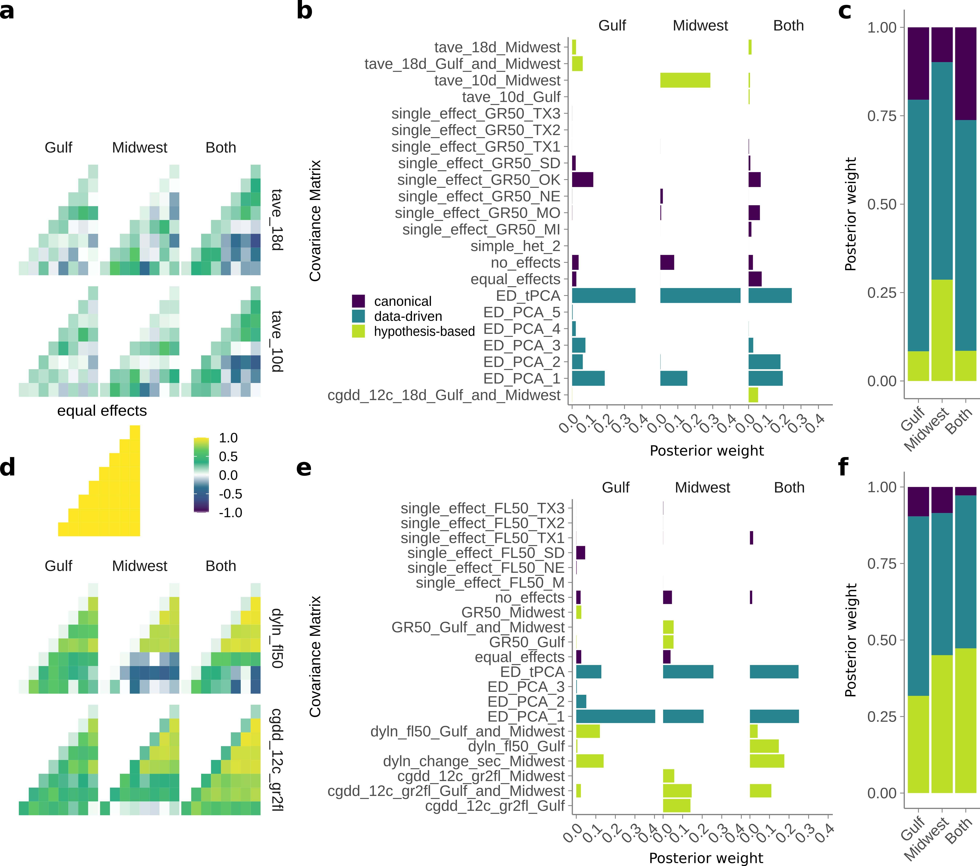

***Figure 3.*** *Effect patterns exhibited by the major data-driven matrices from* ***Figure 2****. (****a,d,g,j****) Gulf (****b,e,h,k****) Midwest, (****c,f,i,l****) Both subgroups. (****a-f****) Green-up phenotype. (****g-l****) Flowering phenotype. (****a-c,g-i****) First two eigenvectors from a singular value decomposition of the ED_tPCA data-driven matrices for gree-nup. First eigenvector corresponds to ED_PCA_1, and second corresponds to ED_PCA_2. Common gardens are arranged in latitudinal order. The percent variation explained of the tPCA by each eigenvector is shown on the y-axis. (****d-f,j-l****) SNPs with significant effects in both conditions that exhibit antagonistic pleiotropy or differential sensitivity between that pair of conditions.*

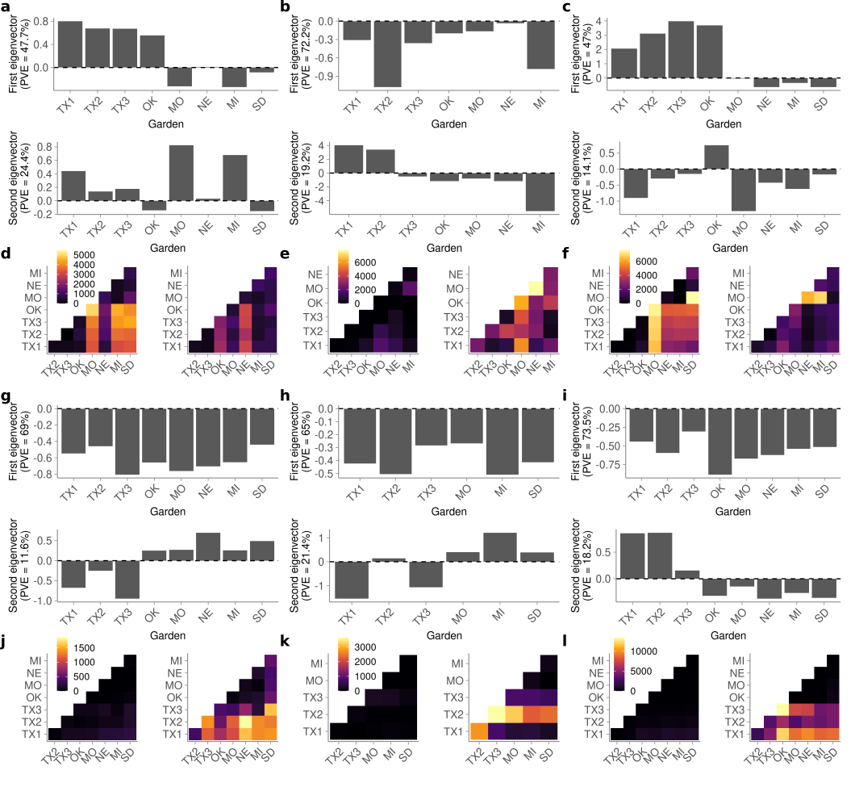

***Figure 4.*** *Comparison of mash SNP effects from a diversity panel and effects from an outbred F2 cross. (****a****) QTL mapping for four weather-related functions of flowering, and for green-up date, as indicated by the colors. Dotted lines indicate permutation-based significance thresholds for each weather-related function. (****b****) Schematic comparison of genotypes used for QTL mapping and genotypes used in mash. (****c****) Number of mash runs enriched for SNPs in the 1% mash tail in the 23 QTL intervals from (****a****) (dotted red line), compared to 1000 sets of 23 random QTL intervals of the same size (histogram). (****d****) SNP effects estimated using mash for SNPs with the highest Bayes factor for the three QTL with the highest LOD scores from (****a****) and enrichment of SNPs in the 1% mash tail. SNP genomic position and genetic subpopulation are indicated above each plot. Common gardens are arranged in latitudinal order. (****e****) QTL effect estimates for 23 non-overlapping and partially overlapping QTLs. Colors indicate which of the four weather-related functions of flowering for which the QTL was mapped. An additional five QTLs completely overlapped the QTL displayed; in this case, the QTL with the highest lod score is shown. Solid vertical lines separate QTLs that are not overlapping. Stars indicate QTL with significant enrichment for SNPs in the 1% mash tail; B, G, and M indicate which subpopulation had enrichment, as in (****b****):B - both subpopulations, G - Gulf subpopulation, M -Midwest subpopulation. Common gardens are arranged in latitudinal order.*

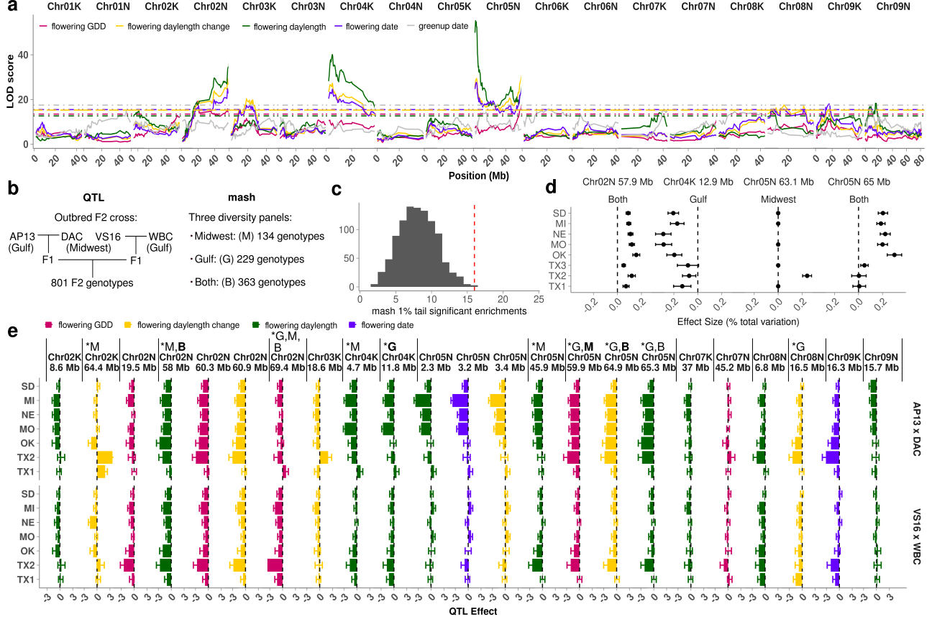

**Table 1.** Green-up and flowering dates as functions of environmental cues.

|  |  |  |
| --- | --- | --- |
| Phenotype | Name | Description |
| green-up | cgdd | Correlations in cumulative growing degree days for the five, ten, or eighteen days prior to green-up. |
| green-up | Temp_ave | Correlations in average temperature for the five, ten, or eighteen days prior to green-up. |
| flowering | green-up | Correlations in green-up. |
| flowering | daylength | Correlations in day length on the day of flowering. |
| flowering | daylength_change_seconds | Correlations in the change in daylength (in seconds) on the day of flowering. |
| flowering | cgdd_greenup_to_flowering | Correlations in cumulative GDD between green-up and flowering. |
| flowering | cumulative_rainfall | Correlations in cumulative rainfall in the one, three, or five days before flowering, or in the days between green-up and flowering. |

|  |  |  |  |  |
| --- | --- | --- | --- | --- |
| QTL | # Contrasts | Overlap flowering GDD QTL? | Sign  Texas vs North | Magnitude  Texas vs. North |
| Chr02K 8.6Mb | 2 | no | Same | Distinct, larger at North |
| Chr02K 64.4 Mb | 1 | no | Different | Distinct, larger at Texas |
|  | 1 | no | Same | Similar |
| Chr02N 19.5 Mb | 2 | yes | Same | Similar |
| Chr02N 58-60.9 Mb | 2 | yes | Same | Similar |
| Chr02N 69.4 Mb | 1 | yes | Same | Distinct, larger at Texas |
|  | 1 | yes | Same | Similar |
| Chr03K 18.6 Mb | 1 | no | Different | Distinct, larger at Texas |
|  | 1 | no | Same | Similar |
| Chr04K 4.7 Mb | 1 | no | Same | Distinct, larger at North |
|  | 1 | no | Same | Distinct, larger at Texas |
| Chr04K 11.8 Mb | 1 | no | Same | Distinct, larger at North |
|  | 1 | no | Same | Distinct, larger at Texas |
| Chr05N 2-3Mb | 1 | no | Same | Distinct, larger at North |
|  | 1 | no | Same | Similar |
| Chr05N 45.9 Mb | 1 | no | Same | Distinct, larger at North |
|  | 1 | no | Same | Distinct, larger at Texas |
| Chr05N 59.9-65.3 Mb | 1 | yes | Same | Similar |
|  | 1 | Yes | Same | Distinct, larger at Texas |
| Chr07K 37Mb | 2 | no | Same | Similar |
| Chr07N 45.2Mb | 2 | yes | Same | Similar |
| Chr08N 6.8Mb | 2 | no | Same | Distinct, larger at Texas |
| Chr08N 16.5Mb | 1 | no | Same | Distinct, larger at Texas |
|  | 1 | No | Same | Similar |
| Chr09K 16.3 Mb | 2 | no | Same | Distinct, larger at Texas |
| Chr09N 15.7 Mb | 1 | no | Same | Distinct, larger at North |
|  | 1 | No | Same | Similar |